### ASSIGNMENT 8:

**Objective** – Power BI Desktop, Cloud Service and End to End Workflow

**Use Case** – Product Information

**Source** – Incomplete Report

**Analytics** – Fill in three-time intelligence functions in a report

**Report/Dashboard** – Product Insights

**Create 3 measures using the table - the screen shot below shows what these should show. Here are the measures you need to create:**

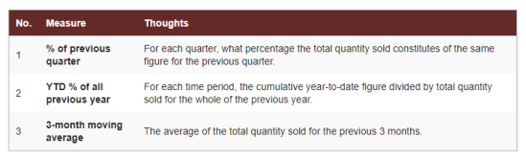

The DAX function used is:

* % change on previous quarter = DIVIDE(SUM(Purchase[Quantity]), CALCULATE(SUM(Purchase[Quantity]),PARALLELPERIOD('Calendar'[DateKey],-3,MONTH)))
* 3-month moving average = CALCULATE(SUM(Purchase[Quantity])/3, DATESINPERIOD('Calendar'[DateKey],LASTDATE('Calendar'[DateKey]),-3,MONTH))
* YTD % of all previous year = DIVIDE(TOTALYTD([Qty], 'Calendar'[DateKey]), CALCULATE([Qty],PARALLELPERIOD('Calendar'[DateKey],-1,YEAR)))

